**Physical Interface Design**

Mini project – Aalborg University  
MED4 2020  
Kristinn Bragi Garðarsson  
Malte Elkær Rasmussen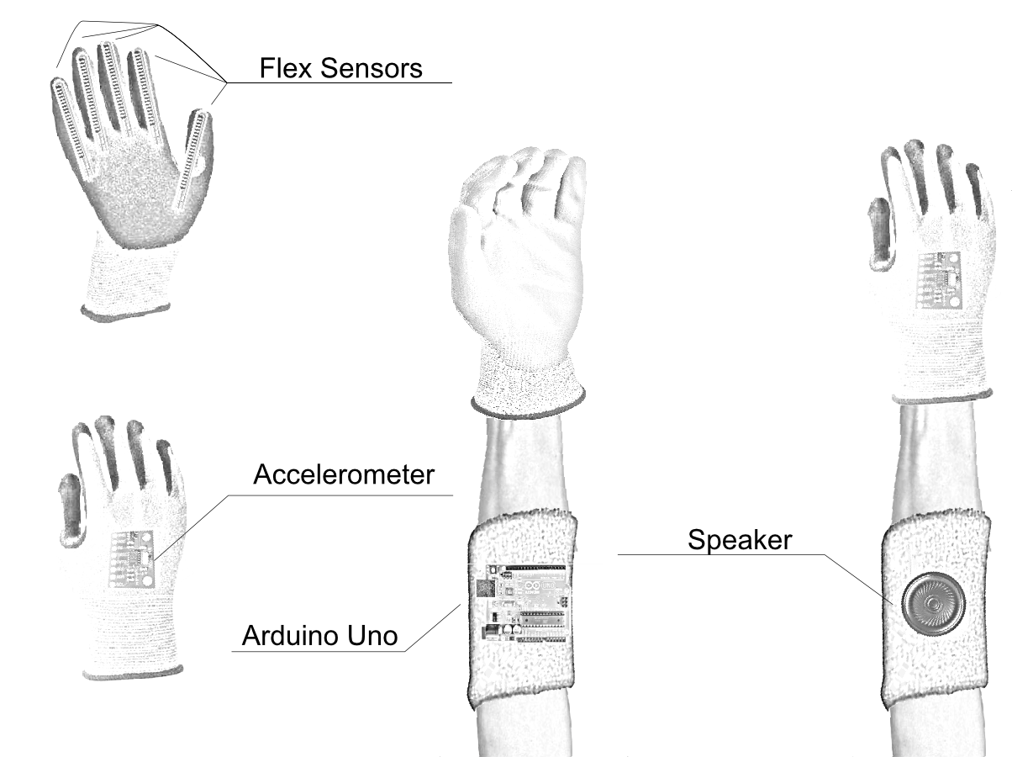

# Introduction

The motivation for the mini project was to create an expressive digital musical instrument controlled with hand movements. Due to lack of resources the project ended up differently than where it started. This paper will explain the initial idea and how the direction changed throughout the duration of the mini project.

# Initial Idea

To conceptualise the project idea Verplank’s (2009) design categories were used, which are visualised on the sketch in figure 1. The initial **idea** was to make a musical controller that represented an accordion to some degree. An **error** of playing a real accordion is that a player could easily get tired when practicing the accordion and it takes up a lot of space making them hard to travel with. When using our controller, it should **metaphorically** feel like you’re stretching some physical material. The ideal **scenario** for our controller would be when practicing or performing. Our controller is **modelled** after an instrument and the **tasks** for controlling it should be the same as when controlling the accordion (i.e. pulling, pushing, and pressing buttons). The **display** of the controller (what it could look like) is two materials to hold and a spring between them connecting them. To **control** the instrument, the force of the spring could be measured. Distance could also be used in the absence of a spring.

**Figure 1**: Conceptualising the initial interaction design idea using Verplank’s interaction design framework.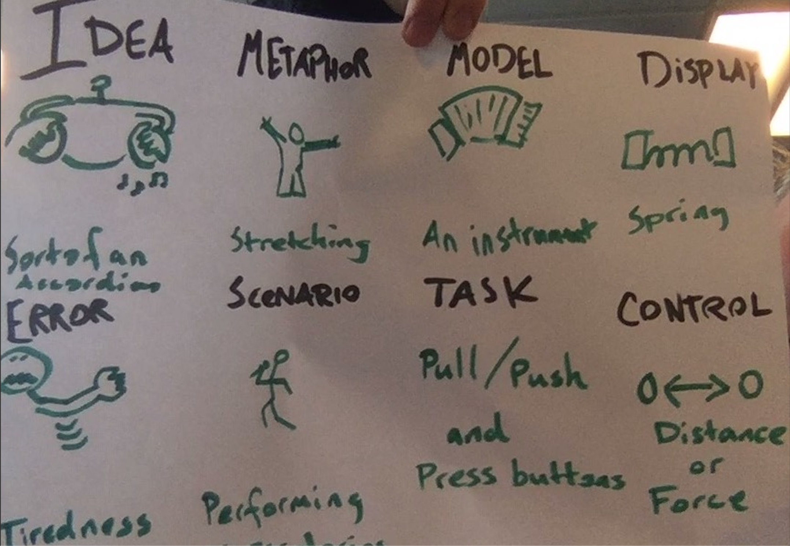

# Hardware

The intention was to make the physical interface so that the interaction would resemble playing an accordion without actually holding a physical object but instead by measuring the movements of hands and fingers. For this, it was decided to use flex sensors for registering bending of the fingers and accelerometer for registering hand movements, as shown in figure 2.

**Figure 2**: Initial sketch of the physical interface design for the instrument. Flex sensors and accelerometer are attached to a glove and an Arduino Uno and speaker are attached to the wrist.

The interface would run with an Arduino Uno, and because of the available amount of analog input pins on the Arduino, we were limited to three flex sensors and one accelerometer. Therefore, it was decided to control the instrument with only one hand. The sensors are attached to a glove with the flex sensors positioned on three fingers (index, middle and ring finger), and the accelerometer is positioned at the back of the hand. The accelerometer used is a triple axis accelerometer model ADXL335[1]. The sensors are then connected to the Arduino, which is attached to the wrist. As shown in figure 2, we intended to connect the Arduino to a small speaker that would be attached to the arm as well, however, it was decided to generate audio from software instead, since this would open up for more possibilities for the audio.

A schematic diagram for the circuit of the instrument is shown in figure 3. The system is powered by the Arduino, so the circuit is connected to the 5V pin and the ground pin. Each flex sensor is included in a voltage divider to produce a variable voltage output to analog pins of the Arduino. This is done using the flex sensors as variable resistors where the resistance is increased when the sensor is bent. Therefore, bending the flex sensor changes the ratio of the resistive values ("Voltage Divider and Voltage Division", 2019).

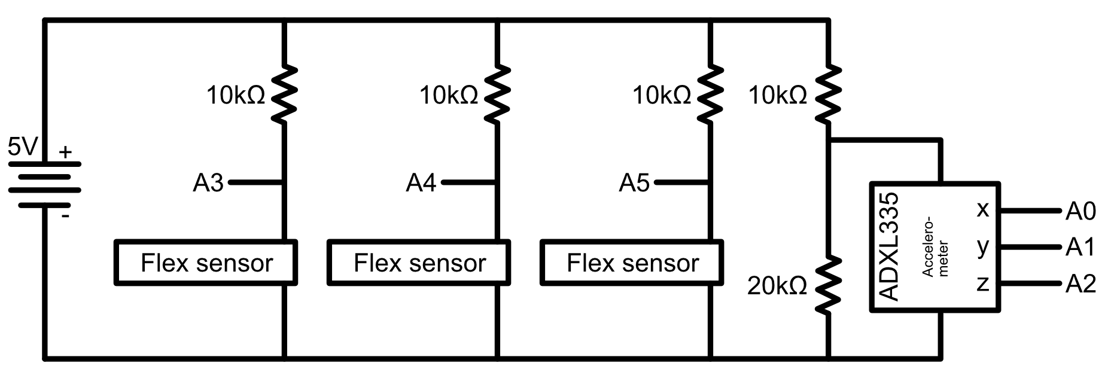

**Figure 3**: Schematic diagram of the circuit. All sensors are included in voltage dividers using resistors.

The accelerometer is also added to a voltage divider, in order to reduce the supply voltage to the accelerometer, since a max voltage of 3.3V is required for the accelerometer. It is therefore added in between a ?? ohm resistor and a ?? ohm resistor to reduce the supply voltage from 5V to around 3.3V, as found from the equation:

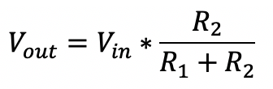

.

The implemented physical interface can be seen in figure 4.

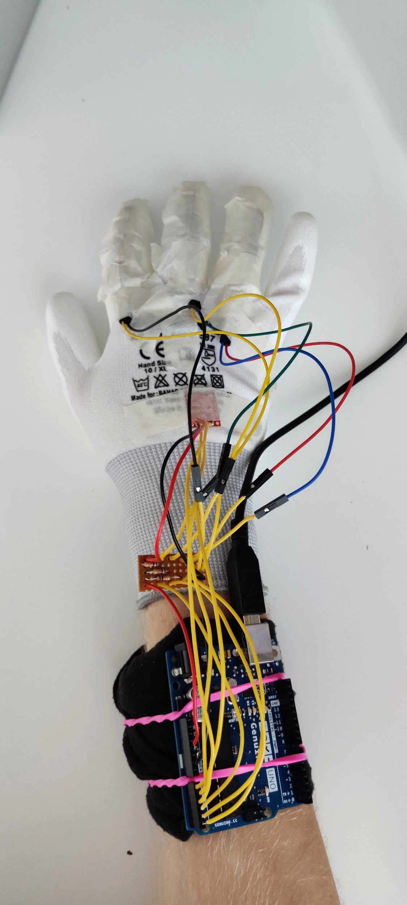

**Figure 4**: Implemented physical interface. Flex sensors are attached to index, middle and ring fingers and the accelerometer is attached to the back of the hand. All sensors are connected to analog pins on the Arduino Uno.

# Software

Audio generation was done in Max. The Arduino software handles readings from the flex sensors and the accelerometer and uses them to calculate values to be sent to a Max patcher through a serial. The flex sensors are to be mapped to the values 0, 1, and 2 representing different bending states of the finger. The three axes of the accelerometer are used to detect movement of the hand. They are also used for detecting rotation. DFRobot[2] explains very well how rotation can be calculated with the accelerometer. By measuring on which axes the gravitational force, *G*, is pulling we can estimate pitch rotation as

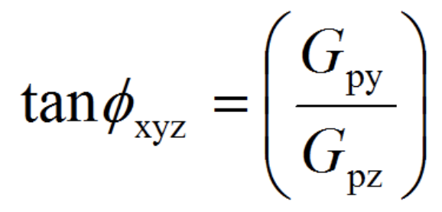

,

where $φ$ is the pitch angle and x, y, and z are the acceleration axes. To smoothen the readings of pitch and acceleration, a running average is calculated in the Arduino software for both values. The code for the smoothing was acquired from an Arduino tutorial[3].

Communication from Arduino to Max is managed with the [serial] object in Max, which receives messages from Arduino with a tagline and a sensor value. The taglines are used to route the values to their desired functionalities.

The audio produced in Max consists of a sawtooth wave and a sine wave layered together using a [phasor~] and a [cycle~] object. The ratio amount of one against the other can be controlled gradually from 1:0 to 0:1. An octave arpeggiator implemented as an effect by dividing the frequency at some time interval and the number of arpeggiated octaves can be controlled. Vibrato was implemented as well by manipulating the MIDI note input by some cents.

### Applying flex sensor to musical functionalities

**Iteration 1, Flex effects:** The continuous signal the flex sensors provided was ideal for controlling effects so the first application of the three flex sensors was to have them mapped to the audio engine effects. One sensor would control the phasor-to-cycle ratio, another control the arpeggiation, and lastly one to control the vibrato amount.

**Iteration 2, Trumpet fingerings:** The initial plan was to have frequency control with the acceleration and rotation, however, it did not allow for a wide range as limitations are put by the amount you can rotate your hand, which is roughly 180 degrees. Therefore, it was decided to use the flex sensors for frequency control instead. This inspiration was taken from the trumpet instrument which has three buttons. The flex sensors were then used to detect two states of the fingers: fully bent and straight.

**Iteration 3, Own fingerings:** The trumpet fingerings put some limitations to pitch control as well. We asked ourselves why we were trying to mimic the trumpet exactly when the possibilities that technology can provide are so many. So we made our own fingerings. These new fingerings follow a C-Major scale and to make more use of the continuous property of the flex sensors by adding a half-bent state. These states were used to make a note sharp or flat. The fingerings for the different notes is shown in figure 5.

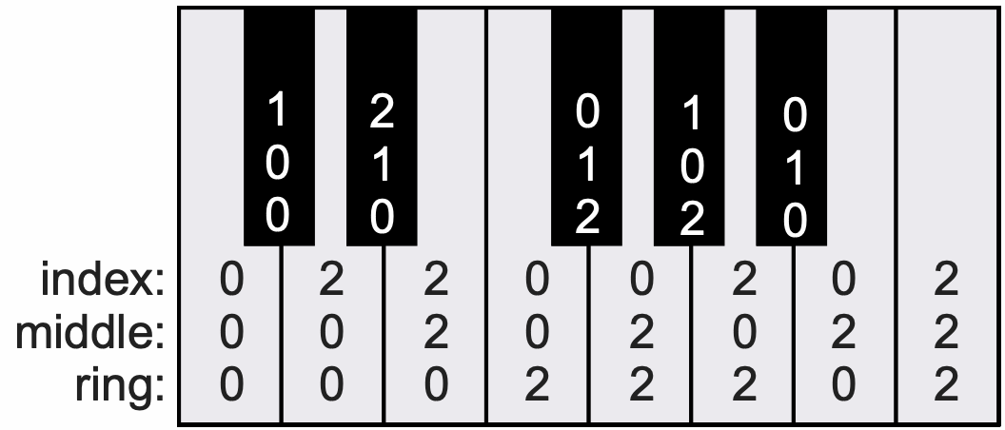

**Figure 5**: Fingerings for playing different notes. 0 represents a straightened state of the finger, 1 a half-bent state and 2 a fully bent state.

### Applying accelerometer to musical functionalities

**Iteration 1, shaking:** The shaking of the hand was applied to produce sound as the wider you would shake, the louder the sound would get. This was applied to mimic the trumpet lip vibration where the faster you shook, the higher pitch you would produce.

**Iteration 2, rotation:** As the shaking didn’t turn out to be very intuitive, we applied pitch rotation to control the volume. This way the player will produce sound by tilting their hand up to a vertical position and stop the sound by tilting their hand back to horizontal position. The shaking input was kept but applied to a vibrato effect instead, where the difference in acceleration was used to define vibrato amount.

# Conclusion

The final musical interface is a nice instrument, useful especially in a performance scenario, as it can provide a lot of expressiveness of the audio using your hand movements. The combination of frequency control from flex sensors, amplitude control from tilting the hand and vibrato when shaking the hand makes it possible to create fluent and natural audio output. The instrument seems very easy to use, since the controls are quite intuitive, however it is still quite difficult to master because you need to get used to the fingerings in order to play expected notes.

The flex sensors are sometimes not registering the correct state, i.e. when the index finger is fully bent it sometimes registers as half-bent. This is most likely due to the material used where tape is not reliable for holding the sensors in the same positions meaning that every time the glove is worn by someone else, the sensors may act differently. Another action to take to prevent this inconsistency would be to tweak the thresholds that dictate the assumed bending state. Applying two different thresholds to pass a state, one for going down which would be a lower threshold than the other for going up, could prevent fluctuations in the recorded sensor values.

At this point, the instrument only covers as low as one octave range. To increase the range of the instrument, and providing more expressive possibilities, a detection of a flick could be implemented. The idea would be that when the player flicks their hand to the right they would go to a higher octave and a flick to the left would lower the notes by an octave.

Using a potentiometer could control effects implemented such as the phasor-to-cycle ratio and the octave arpeggiator. They were however not mapped to any hardware controls as all analog inputs for continuous controls were occupied. A possible solution would be to utilize knobs on a MIDI keyboard to control these effects as it is easily implemented. As it was not a part of the curriculum, it was included.

# Bibliography

Verplank, B. (2009). *Interaction Design Sketchbook*.(2009). Retrieved from

<http://www.billverplank.com/IxDSketchBook.pdf>.

*Voltage Divider and Voltage Division*. (2019, October 28). Retrieved from

<https://www.electronics-tutorials.ws/dccircuits/voltage-divider.html>

1. [https://www.sparkfun.com/products/9269?fbclid=IwAR3n1QbDtvy74g7bpb2qurACcraNH74-GehiGFr7yC UKbR1x7P2WaP81Uv8](https://www.sparkfun.com/products/9269?fbclid=IwAR3n1QbDtvy74g7bpb2qurACcraNH74-GehiGFr7yCUKbR1x7P2WaP81Uv8)
2. <https://wiki.dfrobot.com/How_to_Use_a_Three-Axis_Accelerometer_for_Tilt_Sensing>
3. <https://www.arduino.cc/en/Tutorial/Smoothing>